**CS 451/551 - User Interface Design**

**Fall 2021**

**Assignment 1-a: Locks and Keys**

Authors: Hunter Sutter, Kong Jimmy Vang

## **Problem Statement**

UW-L has many rooms in every building. Almost all rooms have locks which can be opened by physical keys or swipe cards. The term ’key’ is used in this assignment to represent a physical key or a swipe card. The distinction between the two types is made clear wherever it is necessary. Every lock can be opened by at least one key. Every key will open at least one lock. Some keys, called ‘Master keys’, may open more than one lock. Swipe cards cannot be used as Master keys. Hence, all Master keys are physical keys and they can open more than one lock.

In this assignment, a GUI must be developed for a software product that maintains the relationships between locks and keys. Every lock has the following information: lock identification (unique), the room number where the lock is located, and a set of keys (both physical keys and swipe cards) that can open the lock. Each key has the following information: key identification (unique), key type (physical or swipe card), and a set of locks which the key can open.

* Add a new key and a new lock combination to the system. Both lock ID and key ID are auto generated.
* Add a new key to the system and map it to an existing lock. The key ID is auto generated.
* Add an existing key to an existing lock. Since swipe cards cannot open more than one lock, this operation is restricted to only physical keys. Moreover, the key becomes a Master key automatically because, if this operation is successful, the key will open more than one lock.
* Delete an existing key to an existing lock. This operation must ensure that there is at least one other key available to open the lock because every lock must have at least one key.
* Display information
* of a key given its ID - should include its type (physical key or swipe card) and whether or not it is a master key.
* of a lock given its ID - should include the room number where the lock is located.
* of all locks for a given key ID
* of all keys for a given lock ID

## **Assumption(s)**

* Currently, the Locks and Keys software will be assumed to be run on a very secure computer with a login and password and will only be accessible by that computer. In the future, a login and password authentication may or may not be implemented for the software depending on future design specifications.
* The database is assumed to be a set of “HashSet” objects for this assignment.

## **Use Case Diagram**

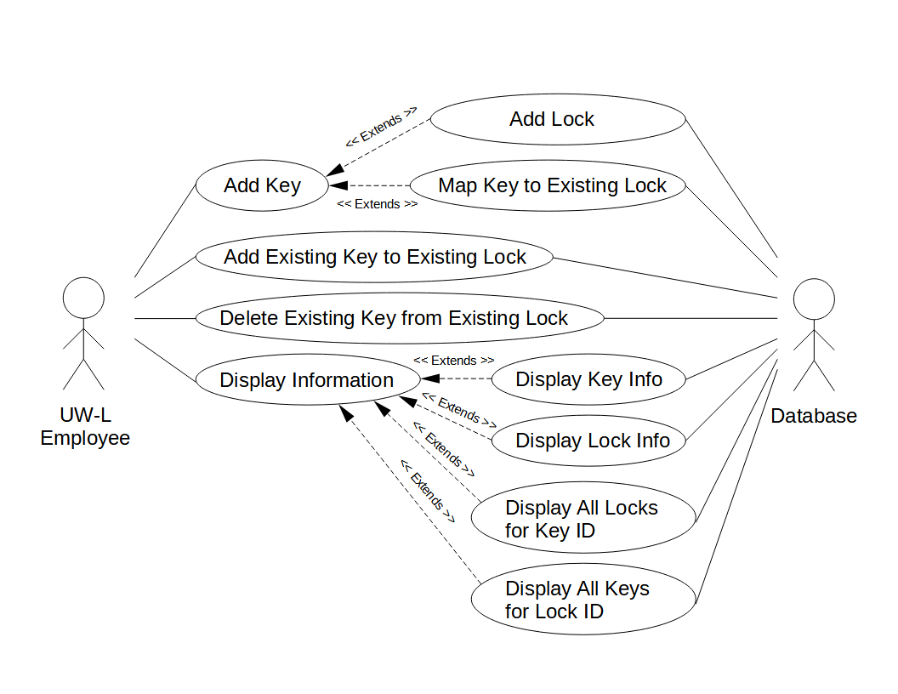

## **Use Case Narratives**

Use Case #: LAK-ADD-K

Use Case name: Add Key

Input parameters: Lock ID, Key Type

Output parameters: None

Successful scenario:

1. The inputs Lock ID are provided by the “Add Lock” use case.
2. The user inputs a Key Type for the key.
3. The Lock ID is then validated.
4. If the lock exists, then the key is mapped to the lock and the user is notified that a key has been added.
5. Auto-generate a Key ID.

Use Case #: LAK-ADD-L

Use Case name: Add Lock

Input parameters: Room number

Output parameters: Lock ID

Successful scenario:

1. The user inputs a room number for the lock.
2. If the lock doesn’t already exist the lock is added and the user is notified that a lock has been created.
3. Auto-generate a Lock ID.
4. Provide output to the “Add Key” use case and invoke it.

Use Case #: LAK-MAP-K

Use Case name: Map Key to Existing Lock

Input parameters: Key ID, Lock ID

Output parameters: None

Successful scenario:

1. The inputs Key ID, Lock ID are provided by the “Add Lock”, which are then passed to the database.
2. The application checks the database to ensure that the lock exists.
3. The map is then updated with the key and lock combination.

Use Case #: LAK-ADD-KL

Use Case name: Add Existing Key to Existing Lock

Input parameters: Key ID, Lock ID

Output parameters: None

Successful scenario:

1. The user inputs an existing Key ID and an existing Lock ID.
2. The system then validates both ID’s to ensure the key and lock exist.
3. The database is then updated to show that the key now works on the existing lock.

Use Case #: LAK-DEL-EX-1

Use Case name: Delete Existing Key from Existing Lock

Input parameters: Key ID, Lock ID

Output parameters: None

Successful scenario:

1. The user inputs an existing Key ID and existing Lock ID.
2. The system checks the database to validate that the key works for the given lock.
3. The existing key is then removed from the set of working keys for that lock.
4. If the existing key being deleted is the last existing key mapped to an existing lock, do not delete the existing key.

Use Case #: LAK-DISPLAY-INFO

Use Case name: Display Information

Input parameters: Key ID, Lock ID

Output parameters: None

Successful scenario:

1. Given a Key ID, invoke the use case “Display Key Info”.
2. Given a Key ID, invoke the use case “Display All Locks for Key ID”.
3. Given a Lock ID, invoke the use case “Display Lock Info”.
4. Given a Lock ID, invoke the use case “Display All Keys for Lock ID”.

Use Case #: LAK-DISPLAY-INFO-1

Use Case name: Display Key Info

Input parameters: Key ID

Output parameters: None

Successful scenario:

1. Given a Key ID, display the key’s type (physical key or swipe card) and whether or not it is a master key.

Use Case #: LAK-DISPLAY-INFO-2

Use Case name: Display Lock Info

Input parameters: Lock ID

Output parameters: None

Successful scenario:

1. Given a Lock ID, display the lock’s room number where it is located.

Use Case #: LAK-DISPLAY-INFO-3

Use Case name: Display All Locks for Key ID

Input parameters: Key ID

Output parameters: None

Successful scenario:

1. Given a Key ID, display all Lock IDs mapped to this Key ID.

Use Case #: LAK-DISPLAY-INFO-4

Use Case name: Display All Keys for Lock ID

Input parameters: Lock ID

Output parameters: None

Successful scenario:

1. Given a Lock ID, display all Key IDs mapped to this Lock ID.

## **GUI Design Sketches (6 Sketches)**

**Page 1 (Home Page)**

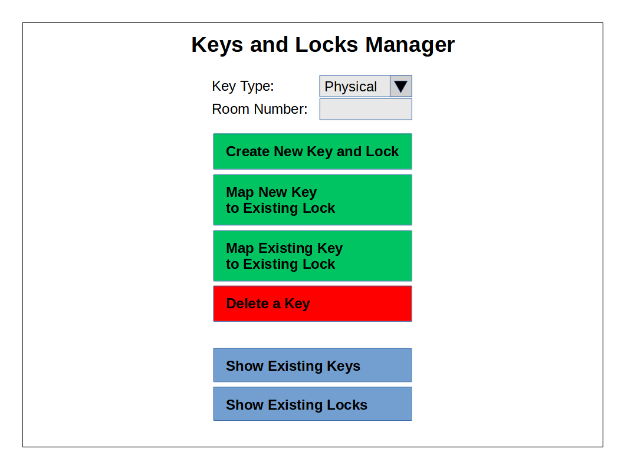

**Page 2 (Map New Key to Existing Lock)**

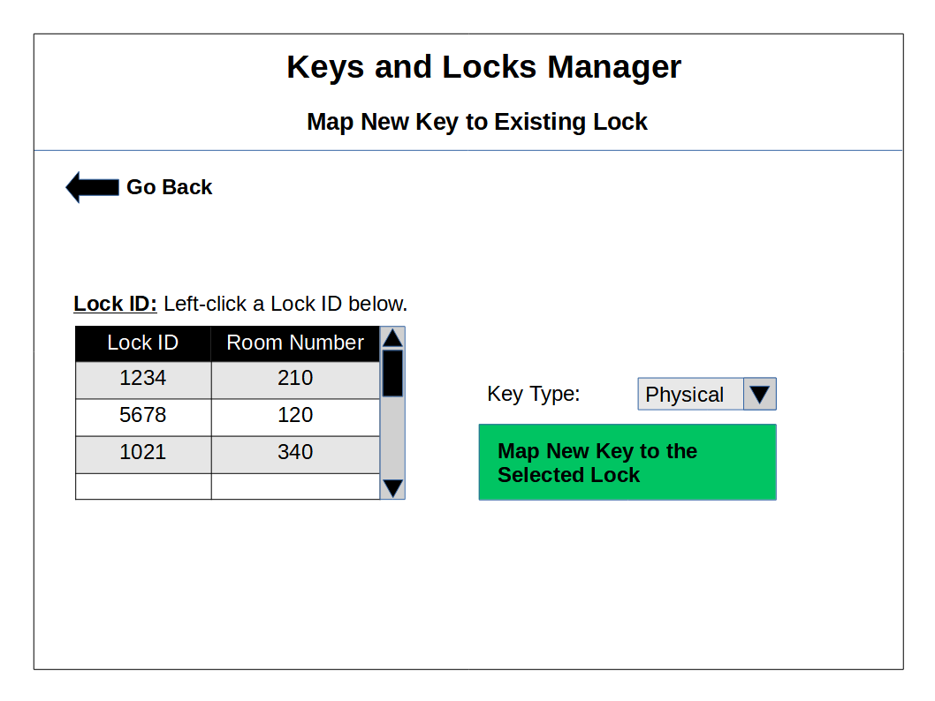

**Page 3 (Map Existing Key to Existing Lock)**

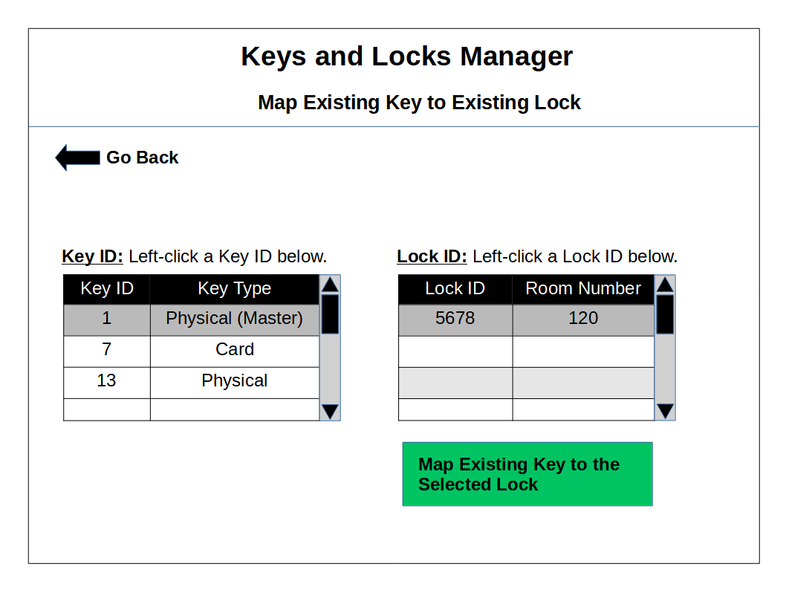

**Page 4 (Delete a Key)**

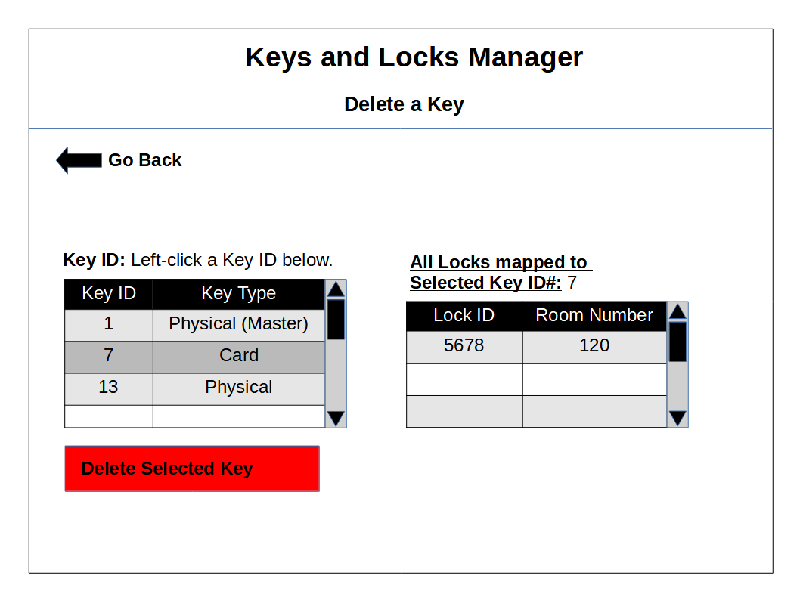

**Page 5 (Keys Information Display)**

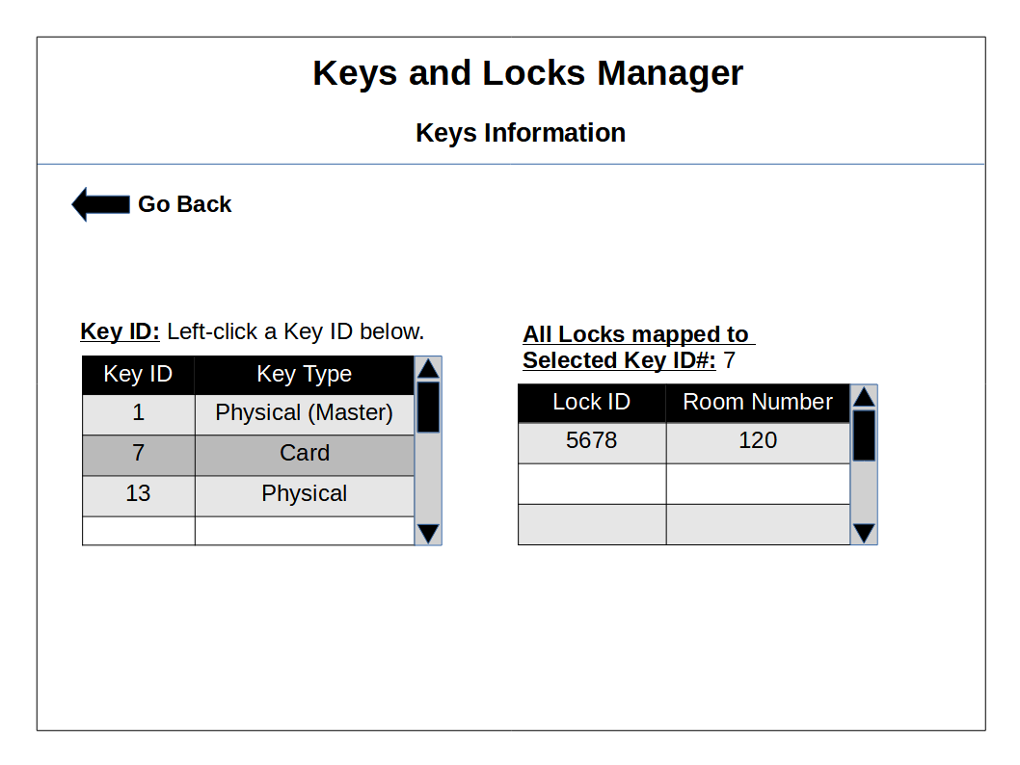

**Page 6 (Locks Information Display)**

